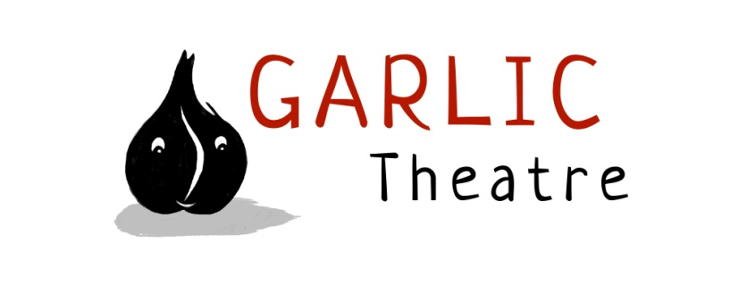

15 Church Lane Wicklewood Wymondham Norfolk NR18 9QH
01953 609141
e-mail: info@garlictheatre.org.uk
www.garlictheatre.org.uk

Jack and the Beans Talk

Inspired by the classic fairytale

Performer Iklooshar Malara

Direction Steve Tiplady

Puppetry direction Liz Walker and Mark Pitman

Music Iklooshar Malara and Jonathan Lambert

Mbira Anna Mudeka

A fresh and funny retelling of the traditional story and an ideal gentle introduction to theatre. For ages 3 - 7

Was it a dream or did I hear a talking bean?
Jack lives on a small farm with his mum and very little to eat. He likes to talk to the birds, his cow and anyone who will listen.
Imagine his surprise when he swops his cow for some magic beans and starts to hear a whispering in the breeze and a giant rumble in the sky ...

Charming and inventive with plenty of interaction, an enormous beanstalk, bags of gold and a smelly old giant
Jack and the Beans Talk is a cautionary tale about what might happen if you throw things out of the window!

From the company that brought you Oldilocks and the Three Bears and The Nosy Little Troll

International Award Winning Puppetry

Copy in 25 words
Jack and the Beans Talk. A charming and inventive show with plenty of interaction, an enormous beanstalk, bags of gold and a smelly old giant.

Copy in 50 words
Jack lives on a small farm with his mum and very little to eat
Imagine his surprise when he swops his cow for some magic beans and starts to hear a whispering in the breeze and a giant rumble in the sky ...
Charming and inventive with plenty of interaction.

Copy in 100 words
Jack lives on a small farm with his mum and very little to eat.
Imagine his surprise when he swops his cow for some magic beans and starts to hear a whispering in the breeze and a giant rumble in the sky.
Charming and inventive with plenty of interaction, an enormous beanstalk, bags of gold and a smelly old giant
Jack and the Beans Talk is a cautionary tale about what might happen if you throw things out of the window!

Duration: 45 minutes

Age Range: 3-7 years

Set Dimensions: 4m (w) 4.5m (d) 3.5m (h)

Get in: 2 hours Get out: 30 minutes

Company 1 cast

Venue Layout: suitable for studio theatre spaces end on for audiences up to 250.

HOW TO BOOK THE SHOW

If you would like to enquire about booking Jack and the Beans talk please contact Iklooshar or Mark on info@garlictheatre.org.uk or telephone 01953 609141

We are committed to treating your data with respect and holding it correctly, in line with GDPR regulations.
To view our privacy policy please click on the link.
https://garlictheatre.org.uk/privacy/

