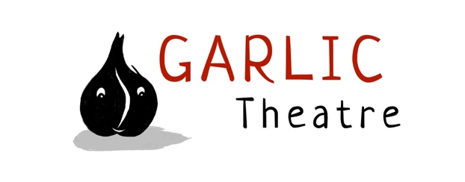

15 Church Lane Wicklewood Wymondham Norfolk NR18 9QH
01953 609141
e-mail: info@garlictheatre.org.uk
www.garlictheatre.org.uk

The Nosy Little Troll
By Garlic Theatre

Deep in the heart of the Norwegian Forest live the trolls – big trolls, tiny trolls and a Nosy Little Troll who has an amazingly sensitive nose…
One day there is a mumbling and a rumbling from the trolls. What is that stinky smell wafting through the trees? The Nosy Little Troll sets off to follow her nose on a quest to solve the mysterious pong. Will she be brave enough to cross the scary old stone bridge and succeed in sniffing out the culprit?

Join us for this funny Scandinavian story starring a tasty brown cheese song, a lost goat and a bushy old troll with green fingers

Garlic Theatre hold their young audience spellbound with wonderfully crafted troll puppets, live music and lots of joining in.

Devised and designed by the Company
Performer Iklooshar Malara
Direction Steve Tiplady
Puppetry direction Mark Pitman and Liz Walker
Music Iklooshar Malara

