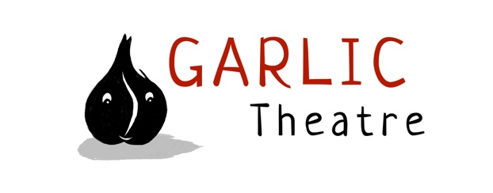

15 Church Lane Wicklewood Wymondham Norfolk NR18 9QH
01953 609141
e-mail: info@garlictheatre.org.uk
www.garlictheatre.org.uk

The Bag that went BOO!
by Garlic Theatre

For ages 3 – 8
The delightfully comic story of a little red bag that jumps out of a brown paper bag – what in the world is it? and where is it going?
Join us for a fantastical journey of paper bag proportions, dive into the sea and travel to the land of snow. Watch out for a giant paper bag wandering about making strange noises….

Garlic Theatre bring a sprinkle of pure magic with mime, clowning and puppetry

Devised and designed by the Company
Performer Mark Pitman
Direction Steve Tiplady
Puppetry direction Liz Walker
Clown consultant Angela de Castro
Music Iklooshar Malara

Wow! It was fantastic. Absolutely captivating - beautiful, simple, spellbinding. This is children’s theatre at its best. The Courtyard Theatre Hereford on 3 Little Pig Tails.

