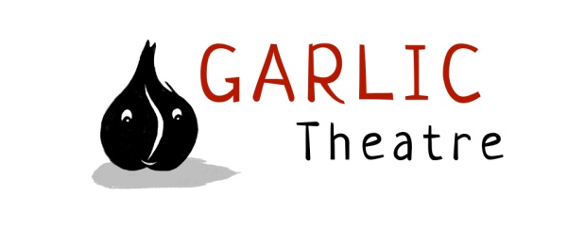

15 Church Lane Wicklewood Wymondham Norfolk NR18 9QH
01953 609141
e-mail: info@garlictheatre.org.uk
www.garlictheatre.org.uk

Shoe Kangaroo

and the Big Bad Boot

Inspired by Spike Milligan and old shoes

Copy for print

Directed by Steve Tiplady,

Puppetry direction Liz Walker

Music Composed by Iklooshar Malara

Performed by Mark Pitman.

For 3 - 9 year olds

Did you ever lose a shoe?
that tumbled into a bird that flew
over the sea to an island new
where creatures strange and mysterious grew
from a wondrous, magical Shoe Kangaroo.

A strapping tale filled with shoes, which promises to be a delightful old load of cobblers

Garlic Theatre take you on a fantastical journey to the island of lost shoes with clowning, mime and beautifully crafted puppets

Duration 47 minutes

Magical transformations and beautifully crafted shoe puppets combine in this bizarre, funny, poetic and imaginative show.

From the company that brought you old Mother Hubbard, Billy Goats Gruff and

There’s A Monster in My Piano

International Award Winning Puppetry

Garlic Theatre tours throughout the UK and abroad reaching annual audiences of 20,000 per year.

‘A quirky imaginative show, wonderfully bonkers! You will never look at your shoes in the same way again’
Rob Allerston Phoenix Theatre

SPECIFICS

Duration: 47 minutes

Age Range: 3 - 9 year olds

Set Dimensions: 4m (w) 4.m (d) 2.5m (h)

Get in: 2 hours Get out: 1 hour

Company 1 cast

Venue Layout: suitable for studio theatre spaces end on for audiences up to 250.

PUBLICITY

High res images and copy are available on the website as well as a promotional video of the show and current tour dates

www.garlictheatre.org.uk

