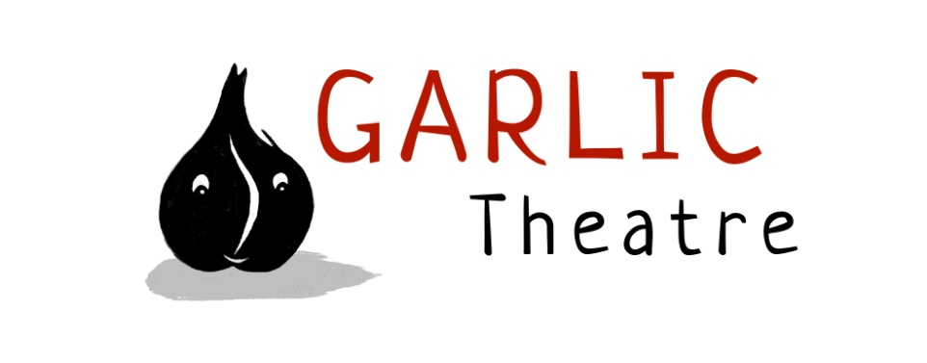
15 Church Lane Wicklewood Wymondham Norfolk NR18 9QH
01953 609141
e-mail: info@garlictheatre.org.uk
www.garlictheatre.org.uk

George and the Dragon
'..to save a maid St George a Dragon slew, a pretty tale if all that's told be true…'
Beware! In a cave under the castle lurks a fiery dragon waiting to devour monks, knights, sheep and …princesses - will George be bold enough to challenge it , or will he run away?
In Garlic Theatre's award winning production, a delicious mix of wit, humour and inventiveness combine to celebrate one of the most famous medieval legends of all time. The production has toured to many Puppet Festivals around the world including Singapore, Taiwan, Brazil and Eastern Europe. With live performance, rod and glove puppetry, masks and music.

Puppet Theatre for ages over five
Running time 45 minutes
Devised and performed by
Iklooshar Malara and Mark Pitman
Direction Mark Bell
Puppetry direction Joy Haynes

