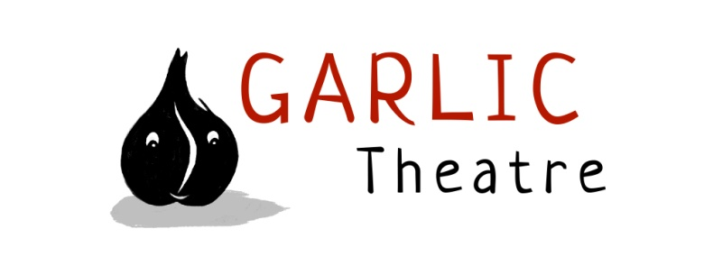
15 Church Lane Wicklewood Wymondham Norfolk NR18 9QH
01953 609141
e-mail: info@garlictheatre.org.uk
www.garlictheatre.org.uk

Old Mother Hubbard and her Cupboard
Copy for print

Inspired by the classic nursery rhyme tale

Directed by Steve Tiplady, Designed by Michaela Bartonova,

Composed by Jonathan Lambert, Performed by Iklooshar Malara

A warm hearted story about an old woman and her dancing dog told with traditional glove puppets for ages 3 - 7

Join Old Mother Hubbard as she clatters about her kitchen hanging out the washing and making breakfast with her dancing dog Oscar at her side.

Their little world of friendship and harmony is interrupted by the squeaking of a little mouse in the cupboard and the fleeting appearance of a mysterious furry paw.

Both are thrilled when they get an invitation to a party, but who sent it and why is it in the deep dark woods?...

Beautifully crafted glove puppets, folk music and enchanting storytelling combine in this interactive slapstick comedy.

From the company that brought you Shoe Kangaroo and the Big Bad Boot, Billy Goats Gruff and

There’s A Monster in My Piano

International Award Winning Puppetry

Garlic Theatre tours throughout the UK and abroad reaching annual audiences of 20,000 per year.

‘We were treated to an amazing feast of puppets with a wonderful mix of slapstick, suspense, audience participation, and high humour ‘ Walsham Le Willows Village Hall

Copy in 25 words

Join Old Mother Hubbard as she clatters about her kitchen hanging out the washing and making breakfast with her dancing dog Oscar at her side.

Copy in 50 words

Join Old Mother Hubbard as she clatters about her kitchen hanging out the washing and making breakfast with her dancing dog Oscar at her side.

Both are thrilled when they get an invitation to a party, but who sent it and why is it in the deep dark woods?...

Copy in 100 words

Join Old Mother Hubbard as she clatters about her kitchen hanging out the washing and making breakfast with her dancing dog Oscar at her side.

Their little world of friendship and harmony is interrupted by the squeaking of a little mouse in the cupboard and the fleeting appearance of a mysterious furry paw.

Both are thrilled when they get an invitation to a party, but who sent it and why is it in the deep dark woods?...

Beautifully crafted glove puppets, folk music and enchanting storytelling combine in this interactive slapstick comedy.

PUBLICITY

High res images and copy are available on the website as well as a promotional video of the show and current tour dates

www.garlictheatre.org.uk

